Page 1 of 3
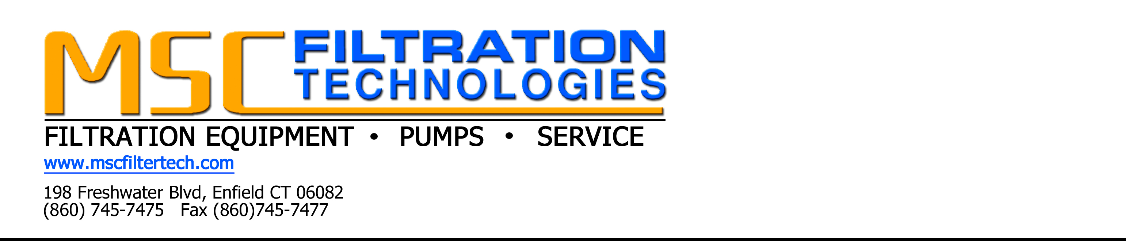
COOLANT FILTRATION QUESTIONNAIRE

Your Name:_______________________________________________________________

Your Email:_______________________________________________________________

Company:_________________________________________________________________

Address:__________________________________________________________________

Phone Number:_____________________________________________________________

- Please Circle your choices below as to what type of filtration solution and technology you are interested in.

- Portable Filtration B. Stationary Filtration C. Centralized Filtration
(Machine to Machine) (Single Machine) System

D. Large Volume Coolant E. Other
Reclaim/Recycling System

If you choose other please describe below.

- What is/are the machining process or processes and what type of material is being machined?

Page 2 of 3 3
COOLANT FILTRATION QUESTIONNAIRE CONTINUED

- Please choose below any filtration/separations equipment already used on your machine/machines?

- No Extra Filtration B. Chip Conveyor C. Paper Bed Filter

D. Magnetic Filter E. Back-washable Filter D. Other

If you choose other please describe below.

- How many machine sumps require filtration and what is their approximate size in gallons?

- Please choose your preferred utility.

- Compressed Air B. 110V 60HZ C. 208-230 60 HZ

D. 480 3 Phase E. Other

If you choose other, please describe below.

- Is Tramp Oil Contamination a problem as well and require removal?

- Yes B. No C. Unsure

Page 3 of 3
COOLANT FILTRATION QUESTIONNAIRE CONTINUED

- Please use the below space to tell us more about your application-available foot space etc. that may not have been covered in the above questions or to submit your own questions to MSC Filtration Technologies.

Thank you for your time and please fax to MSC Filtration at 860-745-7477

